**ASE FALL-2015**

**Assignment-9**

**BY,**

**Yatheeswara Reddy Pulicherla,**

**Class ID : 52**

**Project Deployed on IBM Bluemix:**

URL : <http://trademarketing.mybluemix.net/>

**ScreenShot:**

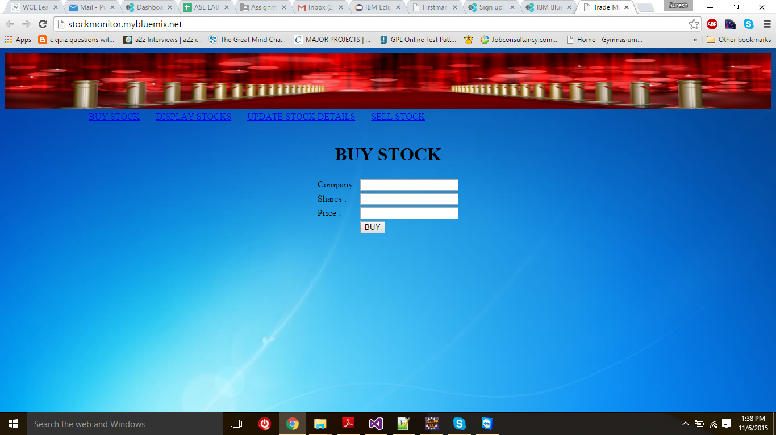

**DESIGN PATTERNS:**

Singloton Pattern:

I have used singleton pattern for keeping the login information of a user.

**ScreenShots:**

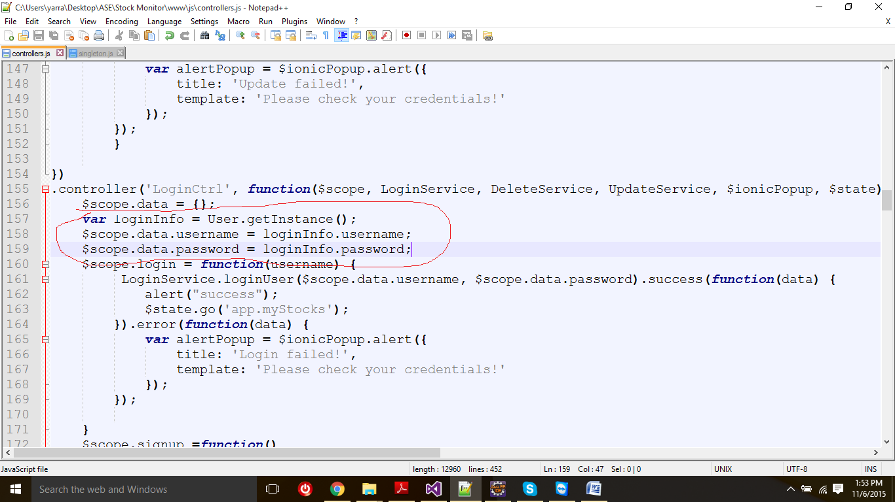

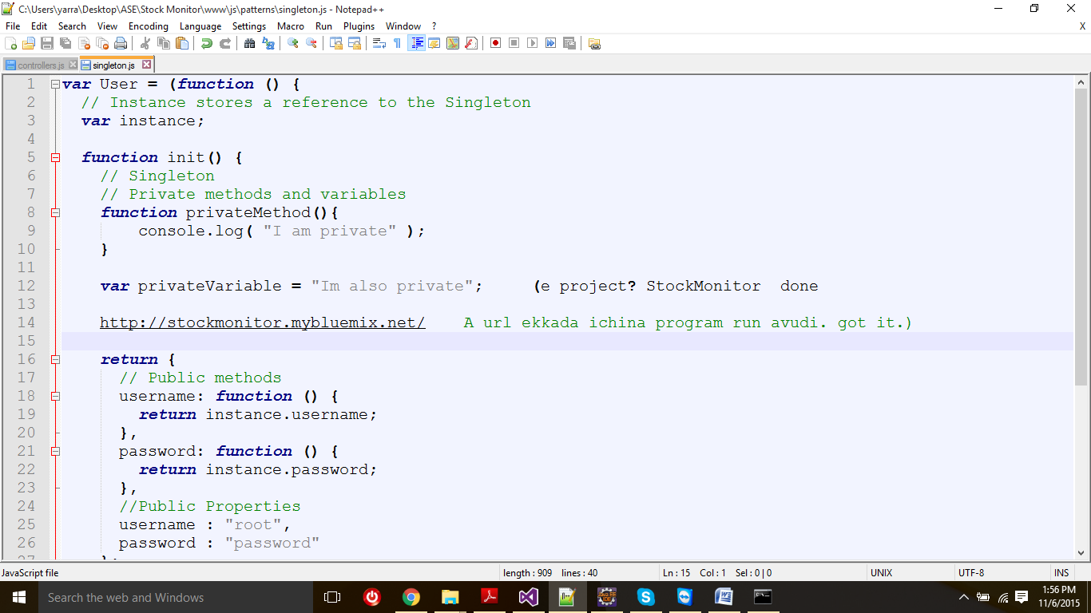

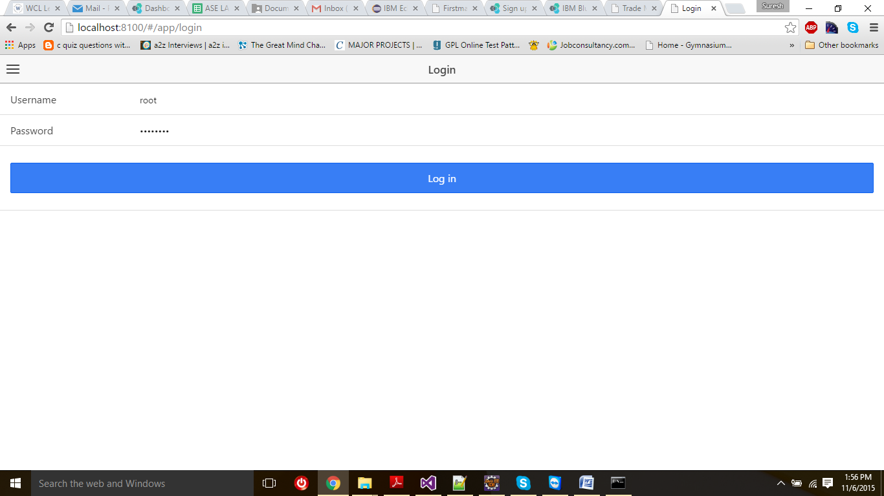

**Mixin Pattern:**

I Have used Mixin Pattern to display the share details.

ScreenShots:

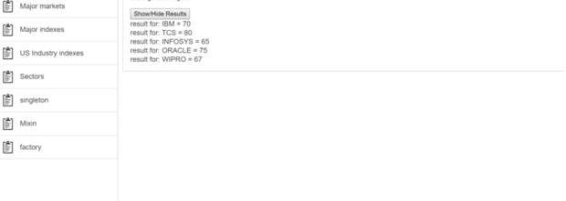

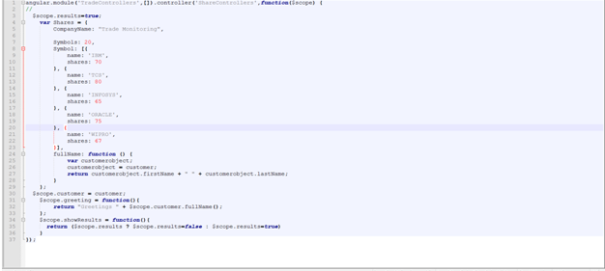

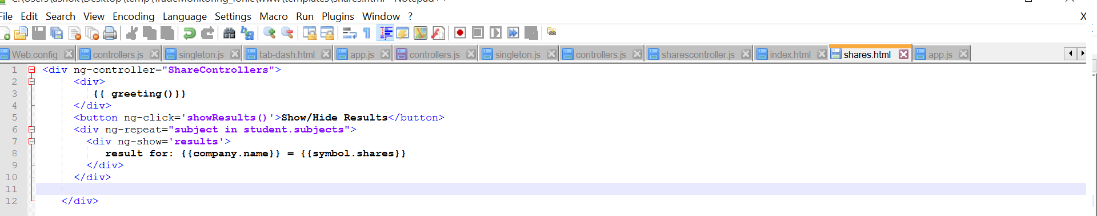

1. **Factory Pattern.**

Factory Pattern I have used to Display the user details and Delete and edit the customer details.

